**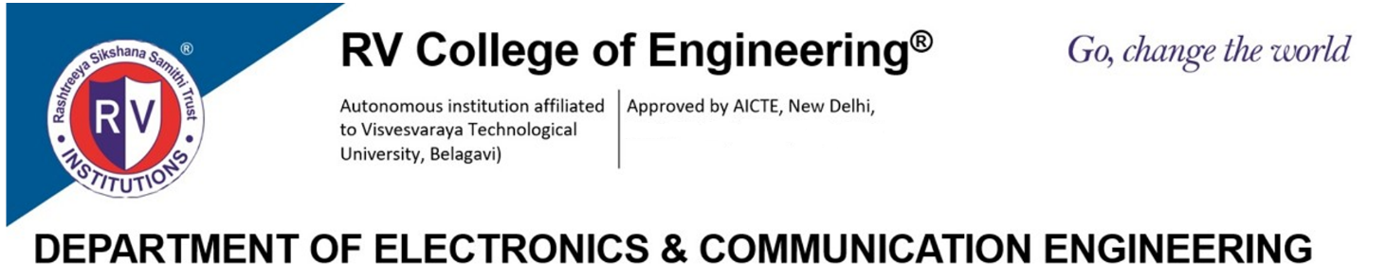****Design and Analysis of**   
**Analog and Digital Circuits**

*AN INTERNSHIP REPORT*

## Submitted by,

### Pavan Kumar C Banasode 1RV21EC116

**Under the guidance of**

**Dr. Shilpa D R**

Associate Professor,

Dept. of ECE

RV College of Engineering

### In partial fulfillment of the requirements for the degree of

**Bachelor of Engineering**

### in

**ELECTRONICS AND COMMUNICATION ENGINEERING**   
**2022-23**

**RV COLLEGE OF ENGINEERING®, BENGALURU-59**

(*Autonomous institution affiliated to VTU, Belagavi)*

### Department of Electronics and Communication Engineering.

### CERTIFICATE

Certified that the Internshiptitled ***‘Design and Analysis of Analog and Digital Circuits’*** is carried out by **Pavan Kumar C Banasode (1RV21EC116),** who is bona-fide student of RV College of Engineering, Bengaluru, in partial fulfilment for the award of degree of **Bachelor of Engineering** **in ELECTRONICS AND COMMUNICATION** of the Visvesvaraya Technological University, Belagavi during the year 2022-23. It is certified that all corrections/suggestions indicated for the Internal Assessment have been incorporated in the report deposited in the departmental library. The report has been approved as it satisfies the academic requirements in respect of Internship work prescribed by the institution for the said degree.

Guide Head of Dept. Principal

Dr. Shilpa D R Dr. H V Ravish Aradhya Dr. K Subramanya  
  
External Viva

Name of Examiners Signature with Date

1.

2.

## DECLARATION

I, **Pavan Kumar C Banasode,** student of third semester B.E., Department of Electronics and Communication Engineering, RV College of Engineering, Bengaluru, hereby declare that the Internship/ Industrial trainingtitled ***‘*Design and Analysis of Analog and Digital Circuits’** has been carried out by me and submitted in partial fulfillment for the award of degree of **Bachelor of Engineering in ELECTRONICS AND COMMUNICATION** during the year 2022-23.

Further I declare that the content of the report has not been submitted previously by anybody for the award of any degree or diploma to any other university.

I also declare that any Intellectual Property Rights generated out of this work carried out at RVCE will be the property of RV College of Engineering, Bengaluru and I will be one of the authors of the same.

Place: Bengaluru

Date: 27.01.2023

Name: Pavan Kumar C Banasode (1RV21EC116)

Signature:



## ACKNOWLEDGEMENT

I am indebted to my guide**, Dr. Shilpa D R,** Associate Professor**,** ECE**,** for his/her wholehearted support, suggestions and invaluable advice throughout this Internship/ Industrial training work and helped in the preparation of this thesis.

I also express my gratitude to my examiner **Name** with designations**,** Department of Electronics and Communication Engineeringfor his/her valuable comments and suggestions.

My sincere thanks to **Dr. H V Ravish Aradhya**, Professor and Head, Department of Electronics and Communication Engineering, RVCE for her support and encouragement.

I express sincere gratitude to our beloved Principal, **Dr. K. N. Subramanya** for his appreciation towards this Internship/ Industrial training work.

I thank all the **teaching staff and technical staff** of the Electronics and Communication Engineering department, RVCE for their help.

Lastly, I take this opportunity to thank my family members and friends who provided all the backup support throughout the Internship training

**Certificate Of Completion**

## 

## 

# 

# SYNOPSIS

Electronics is an area of physics and electrical engineering that deals with the emission, behaviour, and consequences of electrons utilising electronic equipment.   
  
 Modern civilization has evolved significantly as a result of electronics. The semiconductor industry sector is the main engine powering the whole electronics industry.

The main focus of the internship was on the fundamentals of analogue and digital circuits, their design, and analysis using the LTspice simulation software.  
  
 During the course of the internship, all fields of electronics and communication, including analogue, digital, VLSI, embedded systems, SoC, fabrication, etc. Circuits such as CMOS gates, half adder, Full adder, multiplexer, demultiplexer, encoder, decoder, latch etc. were taught, and the same were simulated using the said software during the course of the internship. Assignments and quizzes were also conducted at the end of every week, which helped the students to grasp the behaviour and operation of the various electronic components.

A visit to the IDRC lab at RVCE was supportive towards the understanding of the complexities involved during the process of fabrication and chip manufacturing.

**Table of Contents**

**Page No**

**Synopsis** vi

**1. Profile of the Organisation**

* 1. Centre for Integrated Circuits and Systems 2
  2. Vision 2
  3. Interdisciplinary Research and Innovation 3
  4. Objectives 6
  5. Courses in Curriculum 6
  6. Outcomes 7  
      **2. Activities of the Department**
  7. Modules of Training Programmes 11

2.2 Courses in The Curriculum 12

2.3 Value Addition to Institution 13

2.4 Benefits to the research community 13

2.5 MOUs from COE 14

**3. Tasks Performed**

3.1 Objectives 16

3.2 Week-wise Tasks Performed 17

3.2.1 Week 1 17

3.2.2 Week 2 17

3.2.3 Week 3 18

3.3 About the Project 26

3.3.1 Introduction 26

3.3.2 Design process 27

3.3.2 Challenges faced during project 35

**4. Reflections** 37

**References and annexure** 38

**CHAPTER 1**

**PROFILE OF THE ORGANISATION**

## CHAPTER 1 PROFILE OF THE ORGANISATION

The internship was carried out for 3 weeks in Centre for Integrated Circuits and Systems which specializes design, analysis, and optimization of digital and analogue circuits. With the hardware market booming with the rise of chip-driven products in various fields, the COE offers projects in the areas of Digital, Analog, and Mixed Signal mode VLSI design.

## Centre for Integrated Circuits and Systems

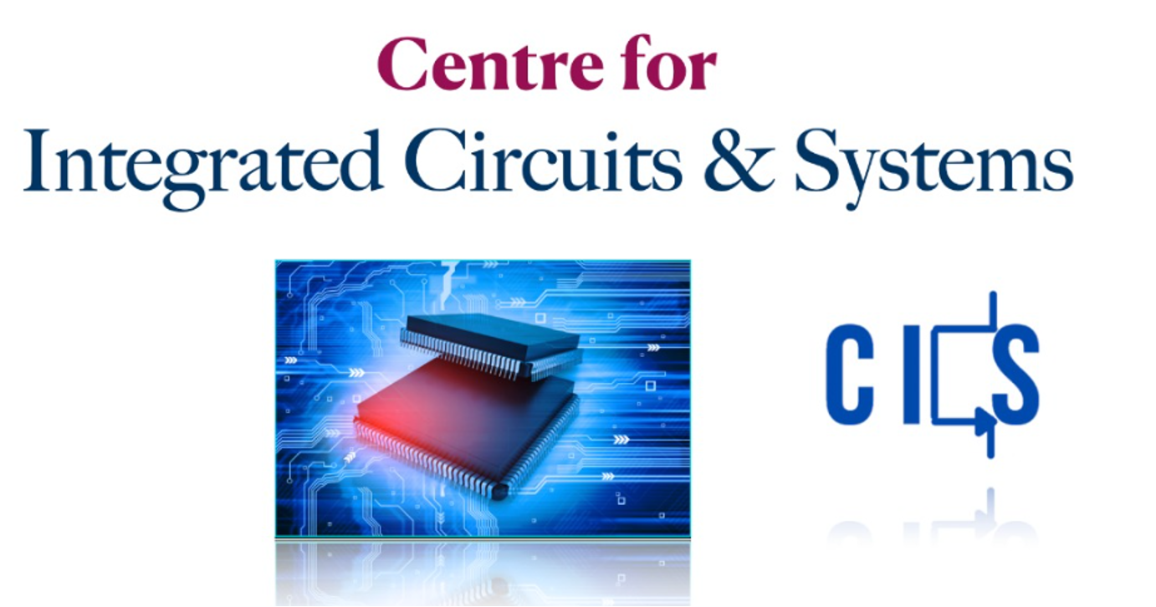

## Fig 1.1 Centre for Integrated Circuits and Systems

The CoE consists of passionate students and faculty members willing to create an ecosystem that inspires the VLSI/Electronics system designer, to nurture the skills and innovative ideas, and to promote sustainable and interdisciplinary research, with inclusive societal concerns. The CoE promotes a coherent training program that enhances the skill set of young designers in the specified areas with academia-industry collaboration in India and abroad. It aims at engaging enthusiastic students in design/development activities through funded projects and consultancy works from various organisations thereby contributing to the growth of the nation.

**1.2 Vision**

Creating an ecosystem that inspires the VLSI/Electronics system designer, nurturing their skills and innovative ideas, and promoting sustainable and interdisciplinary research, with inclusive societal concerns.  
 **1.3 Interdisciplinary Research and Innovation**

Interdisciplinary research is a method of study or research that relies on two or more fields to acquire a more well-developed viewpoint or uncover something new. Interdisciplinary research is gaining prominence and is increasingly seen as necessary. Multiple viewpoints on research difficulties frequently result in better solutions. An inter-disciplinary research centre is an institution or organisation that brings together academics and researchers from several disciplines to cooperate on a specific field of study. These centres frequently focus on cross-disciplinary research initiatives, addressing difficult topics and problems by harnessing the unique viewpoints and experience of scholars from several areas. For the implementation of financed studies and industry consultancy, the institution has taken the following strategy in order to simplify and focus research, to promote proficiency in both students and instructors.

1. Identifying Thematic Areas of Research: Carrying out SWOC analysis of the institution and aligning goals in line with Thrust areas of Govt. & Industry is helping identifying need based areas of research. Thrust areas are identified through road maps, govt. policy documents, Vision 2035, UN SDG 2030, funding agency requirements and such others.
2. Aligning with existing infrastructure and identifying new infrastructure needed: The institution has separate PG / Research budget to cater to new equipment’s and seed funding for students and faculty. Many companies and funding agencies have helped in establishing physical infrastructure and state of the art equipment and software are provided over a period of time
3. Assigning Team: Based on the specialization and competency of the faculty, various interdisciplinary teams are formed to undertake need based research, execute projects and consultancy assignments.
4. Developing Modules and providing training: The newer areas of science and technologies need learning through training from experts. Based on the need of the faculty, training in thematic areas are provided through institutional funding and providing seed funding for initial experimentation & Simulation, wherever needed. Mentoring by Industry & Research Experts in the thematic areas are also taken up for better understanding of the need and execution.
5. Executing work as per standards: Funding agencies and industries expect deliverables in terms of products, processes and systems, which are scalable. Efforts are made to execute the projects and consulting work based on the goals set and measured through publishing in peer reviewed journals, developing prototypes and obtaining Patents and copy rights.
6. Reporting periodically & Scale Up the CoE / CoC: Documentation of the work carried out and submitting to the agencies is a continuous assignment and also helps future work to be undertaken. The whole exercise of interdisciplinary research and innovation is also helping in developing incubation centre and Start-ups for commercialization of IPs, and alternate Revenue generation for sustainability.

**1.3.1 Research Collaboration**

The centre is well-equipped with skilled staff, computing infrastructure, and appropriate open source and commercial teaching learning tools. Figure 1.2 depicts the numerous research domains the CICS is actively a part of. It involves research activities, sensors fabrication, sensors integration, design thinking, and research in the field of IoT and IIOT.

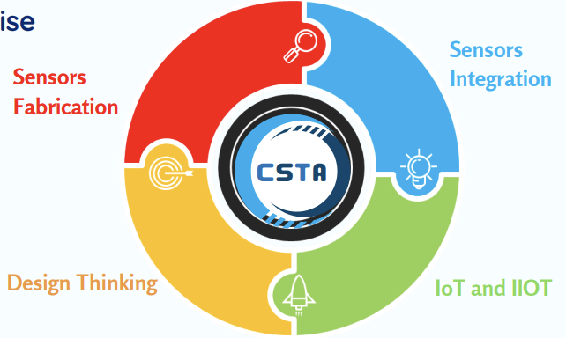

**Fig 1.1** Research domains

**1.4 Objectives**

1**.** To create an eco-system for ultra-low power analog, mixed-signal, RF, and power management services and realize their benefits to society in near future.

2. To promote a coherent program of training that will enhancethe skill set of underprivileged people in the specified areas with academia-industry collaboration in India and abroad.

3**.** To engage in design/development activities by carrying out funded projects and consultancy works for various organisations and thereby partake in the growth of the nation.

4. To establish as a stand-alone centre that can attract people from various domains and leverage substantial interdisciplinary research.

**1.5 Courses in Curriculum**

The circuit branches of Electronics and Communication Engineering, Electrical and Electronics Engineering, Electronics and Instrumentation, and Electronics and Telecommunication have foundation courses in the areas of IC Design in the curriculum, so that any student from the circuit branch can use the facility available in the centre.   
 The Electronics and Communication Department's curriculum includes the center's specialised courses as core and electives. This will give the activities at the centre a boost.

UG Courses

* Analog Microelectronic Circuits
* Analog Integrated Circuit Design
* Radio Frequency and Millimeter Wave IC Design
* Mixed signal IC Design

PG Courses

* Analog Integrated Circuit Design
* Radio Frequency IC Design
* Digital VLSI Design
* VLSI for Testing and Testability

**1.6 Outcomes**

1. Engage in the fabless design of various IP blocks for Analog ICs / Mixed Signal ICs / RFICs / Memory / Digital ICs / SoCs/ASICs.
2. Train students and faculty across India in the areas of Analog ICs / Mixed Signal ICs / RFICs / Memory / Digital ICs / SoCs/ASICs.
3. Engage in R&D projects in the areas of Analog ICs / Mixed Signal ICs / RFICs /Memory / Digital ICs / SoCs/ASICs.

## The chapter highlighted the organization's profile, as well as the research facility supplied to students under the supervision of experienced academics in order to improve students' perspectives on forthcoming newest technologies through inventive and exciting talks at an industry level. The next chapter addresses the department's activities, possible outcomes from the internship, numerous modules and Industry level projects in commercial licensed softwares, as well as the many MOUs formed by COE with the industries for the benefit of students.

**CHAPTER 2**

**ACTIVITIES OF THE DEPARTMENT**

## CHAPTER 2 ACTIVITIES OF THE DEPARTMENT

The activities under the proposed Centre can be categorised in 2 groups.

1. Provide industry certified internship for UG/PG students throughout the year for all 3 modules in the areas of IC Design
2. Fundamental module (1st and 2nd semester UG students of all circuits branches)
   1. Intermediate module (3rd and 4th semester UG students of all circuits branches, 1st semester PG students of VLSI/Communication Branch)
   2. Advanced module (5th and 6th semester UG students of all circuits branches, 2nd and 3rd semester PG students of VLSI/Communication Branch)
3. Execute consultancy projects with the companies that we have tied up with. This will help PG/UG students to work on industry related projects which will give them better exposure to the state of the art work.
4. Apart from regular workshops, the centre can float specialised certificate programmes in various areas of IC Design in the following years as it is of huge demand.

The specialised certification programmes can be run in online / offline mode with 3 Core courses and 2 Elective courses, with capstone projects. The centre will focus on a handful of activities in future as shown in Figure

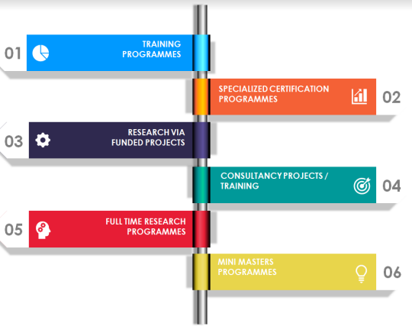

**Fig 2.1.** Activities under the proposed centre

**2.1. Various modules of training programmes:**

|  |  |  |
| --- | --- | --- |
| **Module 1: Analog Design** | **Level 1** | Introductory course on Analog IC Design with hands on using simulators |
| **Level 2** | “Op-amps for everyone” with hands on simulators |
| **Level 3** | Design of low power analog modules with bias generation with hands on using simulators |
| **Module 2: Mixed signal Design** | **Level 1** | Introductory course on Mixed signal IC Design with hands on using simulators |
| **Level 2** | “Data converters for everyone” with hands on using simulators |
| **Level 3** | Design of ADC/DAC Architectures from specifications with hands on using simulators |

**2.2. Courses in the curriculum**

The circuit branches of EC, EE, EI and ET have the foundation courses in the areas of IC Design in the curriculum so that any student from circuit branch can make use of the facility available in the centre. The curriculum of ECE has the specialised courses of the centre as core and electives. This will bring in momentum to the activities in the centre.

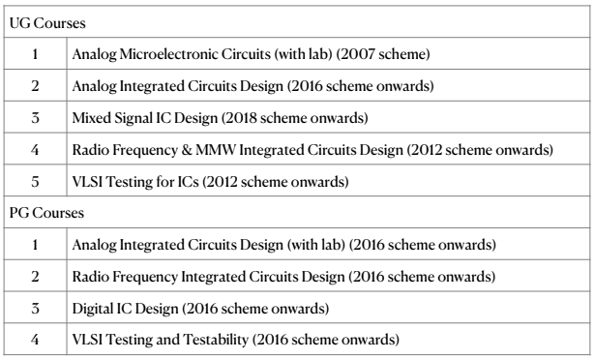

**2.3. Value Addition to the Institution**

The COE brings value addition to the institution.

1. By enhancing research, consultancy works in the proposed themes and domains.
2. By offering training programmes to students of all disciplines from the various modules offered by the centre and can carry out design projects in the centre.
3. Through funded projects from public and private sectors.
4. By promoting PG and full time PhD through research activities.
5. By offering value addition to the degrees offered by the institution through projects, training programs, workshops, symposiums.
6. Fabricated chips will be added to the chip gallery of the centre which can elevate the centre to a hub for IC Design.

**2.4. Benefits to the research community**

The centre provides benefits to the research community in the following ways.

1. Students / Faculty, both internal and external, can take up the structured training programmes enhancing the research activities.
2. Research scholars can use the facility of the centre for their research.

**2.5. MOUs from COE**

The centre has signed MOUs with

1. Entuple technologies to assist the centre with fabless design. This will be done by the experts in the appropriate field from entuple technologies.
2. Lekha Wireless solutions which will offer consultancy projects and internships to the students from RVCE.
3. WPIF which will offer internships to students
4. SCL technologies have offered 180nm PDK.

The chapter discussed the potential outcomes of the internship with industry level projects, the benefits to the research community, and the value added to the institution through a possible publication and innovative projects carried out by students for the welfare of the community, adding a significant status to the institution. The next chapter focuses on the tasks completed during the Internship, followed by the Internship's attained learning outcomes.

## 

## 

## CHAPTER 3

## TASKS PERFORMED

## 

## CHAPTER 3 TASKS PERFORMED

## This chapter includes all the tasks performed in the internship and discusses the objectives, design, implementation and results compared with expected outputs.

## 3.1 Objectives

The objectives covered during the course of the internship were as follows: -

1. To understand the basic rules and laws commonly used in the designing and analysis of circuits, namely Kirchhoff’s voltage law, Kirchhoff’s current law, DeMorgan’s theorem and many more.
2. To understand the behaviour and operation of linear and non-linear electronic components such as resistor, capacitor, inductor, diode, MOSFET, operational amplifiers, etc.
3. To understand the behaviour and operation of digital combinational and sequential logic circuits such as gates, multiplexers, encoders, decoders, latches, etc.
4. To design circuits using the above components and to analyse them using the Ltspice software by running simulations

## Week-wise Tasks Performed

## WEEK 1

* Introduction to the field of electronics and its various branches.
* Basics of networks including KCL and KVL were refreshed.
* An introduction to digital electronics was given, where information regarding basics were taught.
* A hands-on interactive session was held to introduce LTSPICE.
* Testing for linearity of various electronic components (Resistor, Capacitor, Inductor) was carried out.
* Quiz conducted regarding the sessions held.
  + 1. **WEEK 2:**
* A webinar on “*INTRODUCTION TO MICRO/NANO-FABRICATION TECHNOLOGY WITH DEVICE EXAMPLES*” was conducted by Ms. Sabhiha Sultana, Prof., IISc, *CeNSE (Centre for Nano science and engineering),* organised by IEEE RVCE, CAS as a part of the internship at CICS.
* Several important microfabrication techniques such as photolithography, soft lithography, bonding, etching and film deposition were talked about.
* A quiz on the webinar had been conducted.
* Sessions on rectifiers, full wave and bridge rectifiers using diodes, were conducted by the faculty. The same were tested and analysed in the LTSpice simulation software.
* Sessions on digital electronics were conducted which covered the working of multiplexers, decoders and encoders.
* During the end of the second week, a session on the behaviour and operation of MOSFETs was conducted.
* The concept of channel length modulation was introduced, which was later tested & verified in the LTSpice software, by varying the aspect ratio.
  + 1. **WEEK 3:**
* In the final week, the students were asked to choose a project of their choice and work on it for the entire week.
* The finished project files, along with the simulation and log files, were submitted to the faculty in charge, based on which the completion of the internship was determined.

The circuits that were rigged up in the software, simulated and analysed were

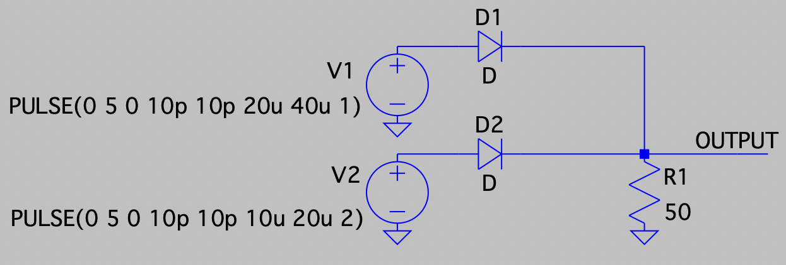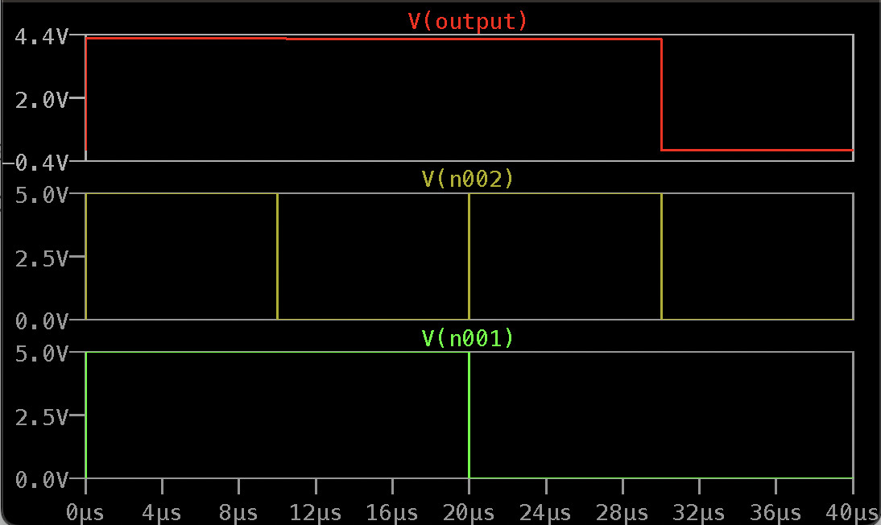

**Fig 3.1.** OR Gate using diodes and related waveforms

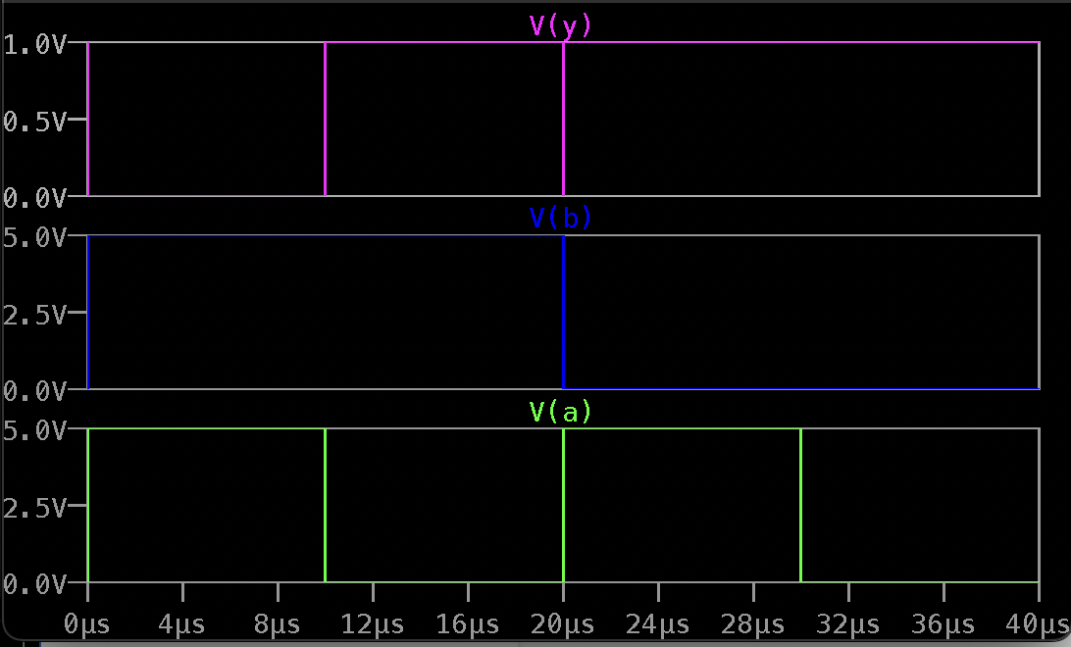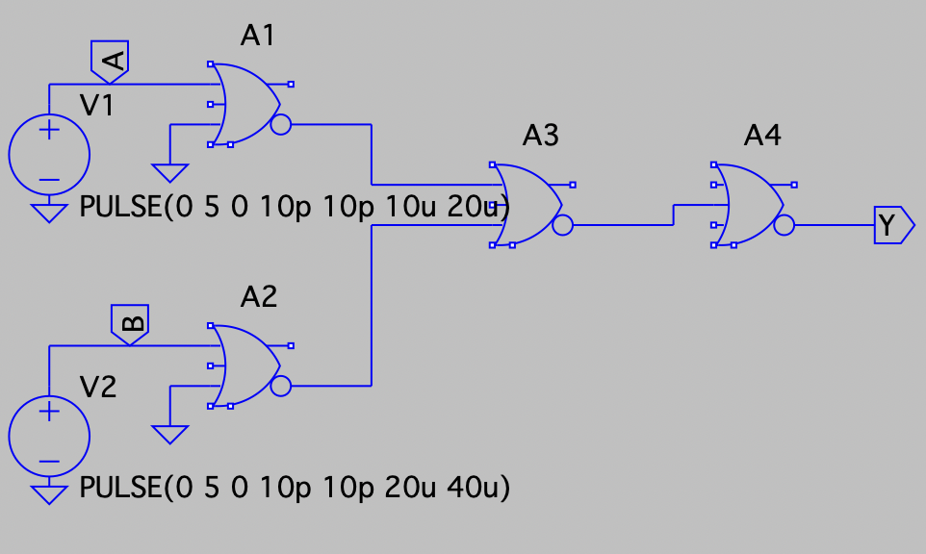

**Fig 3.2.** AND gate using NOR gates and related waveform

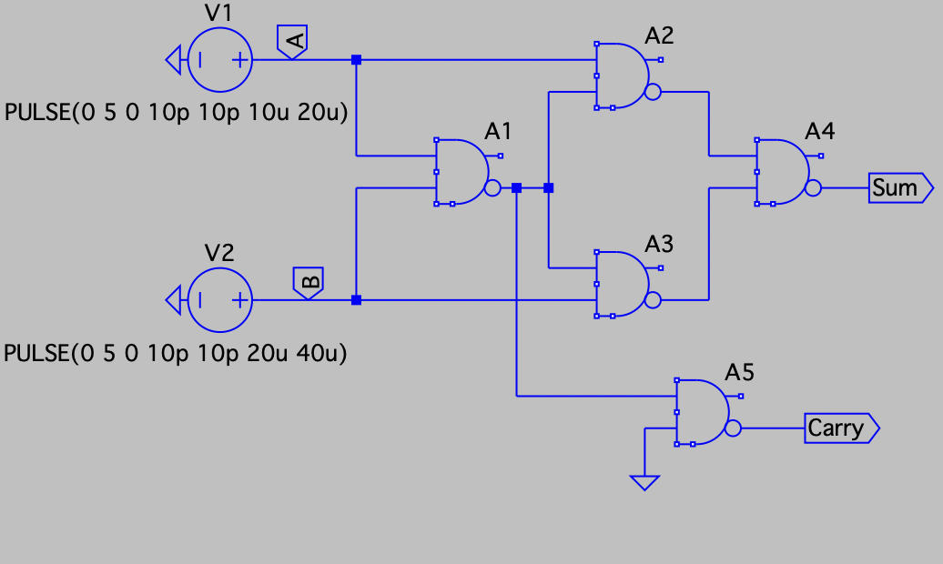

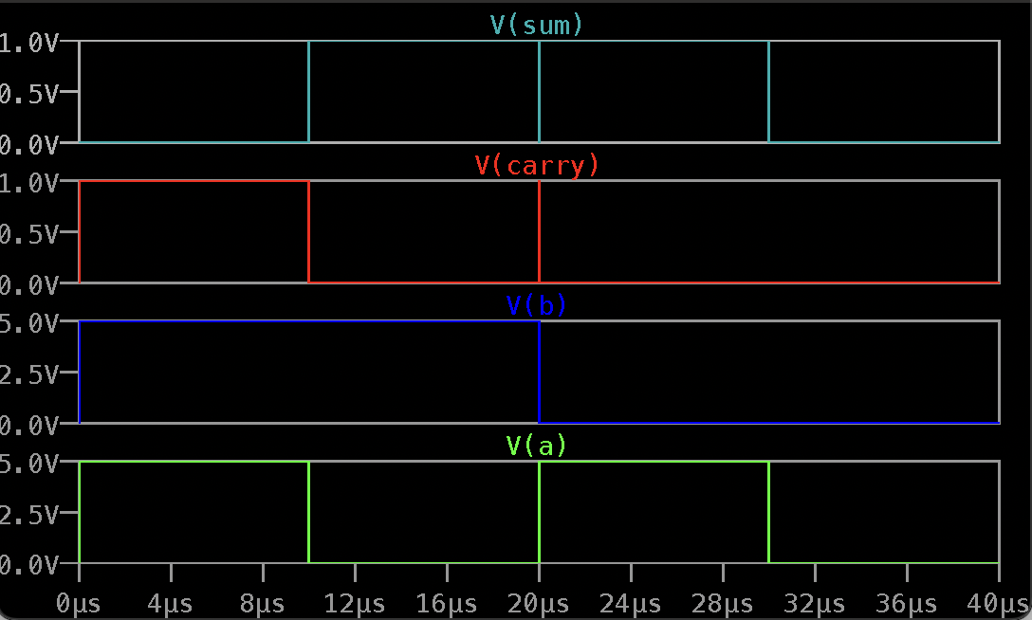

**Fig 3.3.** Half Adder and related waveforms

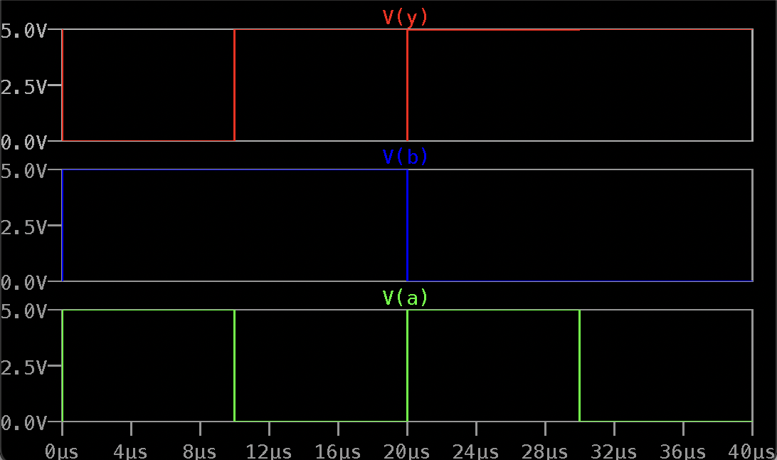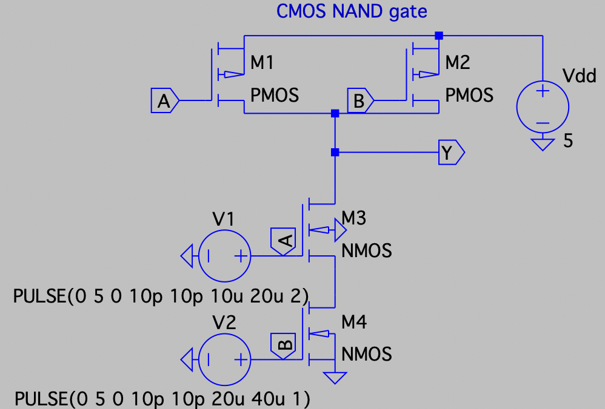

**Fig 3.4.** CMOS NAND gate and related waveforms

### Fig 3.5. OR gate using CMOS gates, and related waveforms

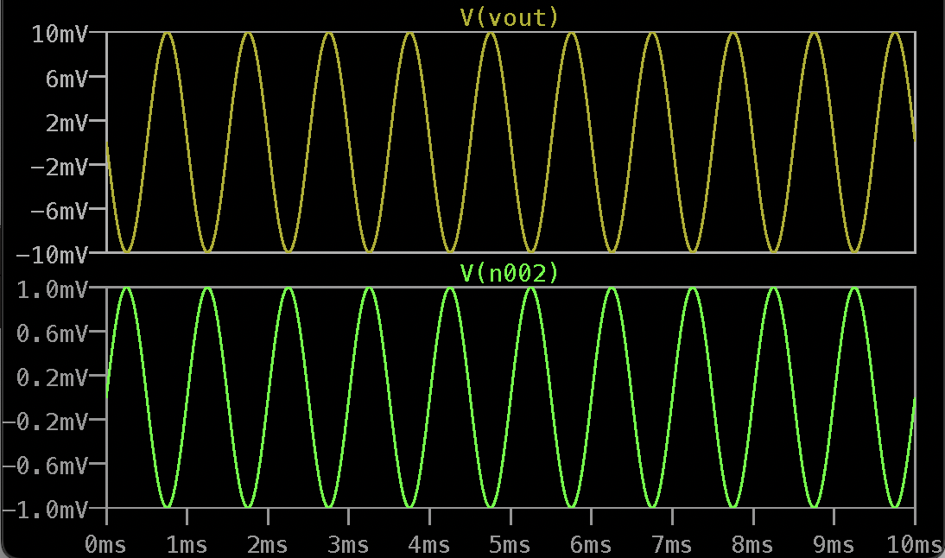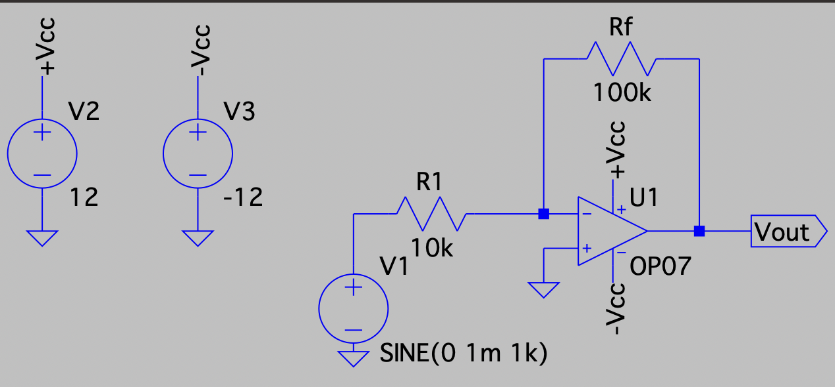

**Fig 3.6.** Inverting Amplifier using Op-Amp

### 

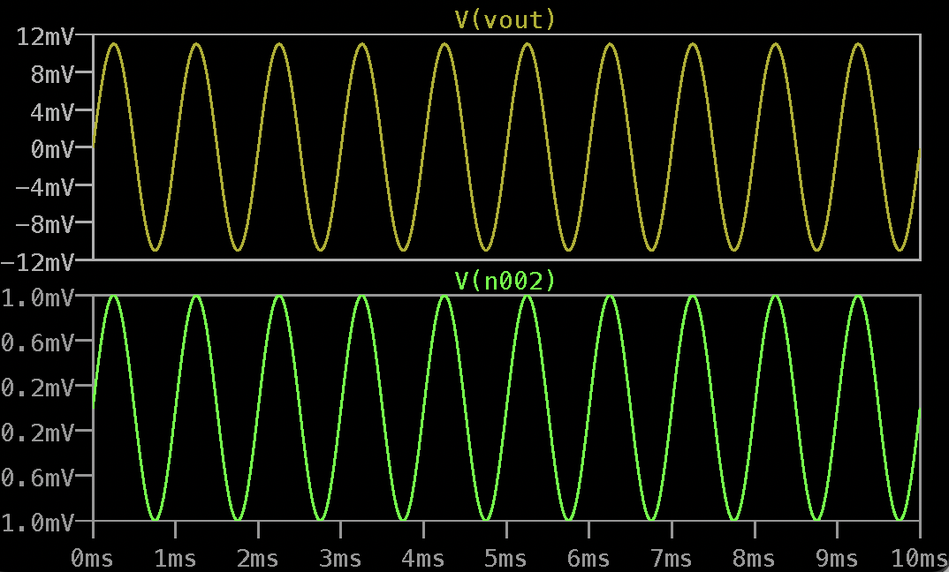

**Fig 3.7:** Non-inverting amplifier using Op-Amp

**3.3 About the Project**

The project that Pavan Kumar C Banasode (myself) chose was to build and test an RC Coupled Amplifier for a Gain of 100 (40dB)

**3.3.1 Introduction**

A transistor type known as a bipolar junction transistor (BJT) employs both electrons and electron holes as charge carriers. A bipolar transistor can be used for switching or amplifying by allowing a little current to be injected at one of its terminals to control a much greater current flowing between the terminals.

A resistance capacitance coupled amplifier (RCCA) is a multi-stage amplifier circuit that is widely used in electronic circuits. The different stages of the amplifier are linked together using a resistor-capacitor combination, thus the term RC Coupled. Figure 3.8 shows a single-stage RC Coupled amplifier, in common-emitter configuration. The resistors R1, R2, RC and RE provide the necessary DC bias to the circuit. The capacitors C1 couples the input to the base of the transistor and capacitor C2 couples the output of the first stage to the next stage, as input. Capacitor CE acts as a bypass capacitor, allowing only ac to flow through it and blocking all DC current.

In the common-emitter configuration of amplifier, the output is 180° out of phase with the input. Hence, a positive going half-cycle at the input will produce an amplified negative going half cycle at the output.

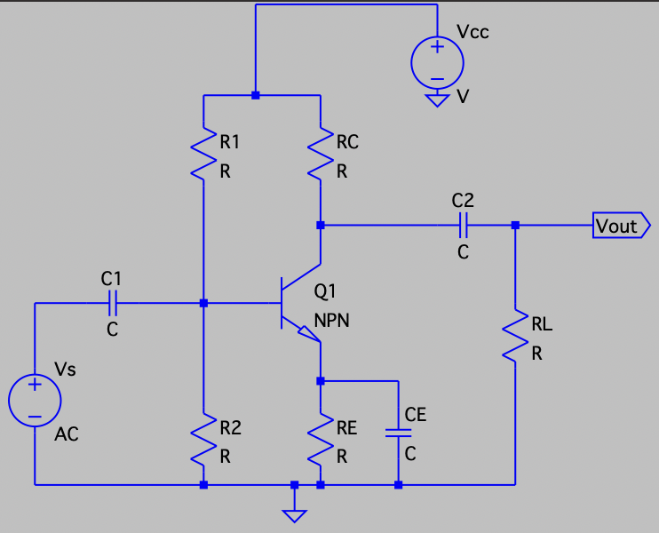

**Fig 3.8:** Single stage RC Coupled amplifier

**3.3.2 Design Process**

Step 1: Selection of transistor

* Since the objective was to design the amplifier for a gain of 100, the current gain of the transistor should be around 100.
* The feasible transistors available for the said application in the LTSpice software were BC547B, BC847B, 2N2222.
* Among the choices, BC547B satisfied all the requirements for the specification.

Specifications of the transistor:

$$h_{fe}(dc)=200{ h}_{fe}\left(ac\right)=220$$

$$h_{ie}=3.2kΩ. V_{CE}=0.25V$$

Step 2: Calculation of $R_{C}$

Gain $A_{v}= -\frac{h_{fe}}{h_{ie}}*R_{C}$

$$-100= \frac{-220}{3200}*R_{C}$$

$$R_{C}\left(std\right)=1.5kΩ$$

Step 3: Selection of Q-Point

$V_{CC}=16V (assumed)$

$$V_{CE-Q}= \frac{V_{CC}}{2}$$

$$V_{CE-Q}= \frac{16}{2}=8V$$

$$V_{RE}=10\% of V_{CC}$$

$$V_{RE}=1.6V$$

$$Current I_{c}= \frac{V_{CC}- V_{CE-Q}- V_{RE}}{R_{C}}$$

$$∴ I_{C}=4.267mA$$

$$Q-Point is Q(8V, 4.267mA)$$

Step 4: Calculation of $R_{E}$

$$V_{RE}= I_{C}*R_{E}$$

$$⇒R_{E}= \frac{1.6V}{4.267mA}=374.9Ω$$

$$R_{E}\left(std\right)=350Ω$$

Step 5: Calculation of values of voltage divider resistors, $R_{1}$& $R_{2}$

Stability factor, $s=8 (assumed)$

$$s=1+ \frac{R_{Th}}{R_{E}}$$

$$⇒8=1+ \frac{R_{Th}}{350}$$

$$⇒R_{Th}=2.45kΩ$$

$$V_{Th}= V_{BE}+ V_{RE}$$

$$⇒ V_{Th}=0.7+1.6$$

$$∴ V_{Th}=2.3V$$

$$R_{Th}= \frac{V_{Th}}{V_{CC}}*R_{1}$$

$$⇒2450=\frac{2.3}{16}* R_{1}$$

$$∴ R_{1}=17kΩ$$

$$Also, R_{Th}= \frac{R_{1}{*R}_{2}}{R_{1}+ R_{2}}$$

$$∴ R_{2}=2.86kΩ$$

Step 6: Calculation of values of Capacitors $C_{1}$& $C_{2}$

$$Lower cut-off frequncy, { f}_{L}=20Hz (assumed)$$

$$C_{1}= \frac{1}{2πf_{L}R_{eq}}$$

$$R_{eq}= R_{Th} \left| \right| h_{ie}$$

$⇒R_{eq}=2.45kΩ \left| \right| 3.2kΩ$

$$⇒ R_{eq}=1.387kΩ$$

$$∴ C_{1}= \frac{1}{2*π*20*1387}$$

$$⇒ C_{1}=5.737μF$$

$$C_{2}= \frac{1}{2πf_{L}R_{C}}$$

$$⇒ C_{2}=\frac{1}{2*π*20*1500}$$

$$⇒ C_{2}=5.35μF$$

$$C_{E}= \frac{1}{2πf_{L}R_{E}^{'}}$$

$$R_{E}^{'}=\left(\frac{R_{Th} \left| \right| h_{ie}}{h_{fe}+1}\right) \left| \right|{ R}_{E}$$

$${⇒R}_{E }^{'}=\left(\frac{2.45kΩ \left| \right| 3.2kΩ}{220+1}\right)\left| \right|350Ω$$

$${⇒R}_{E}^{'}=6.168Ω$$

$$∴ C_{E}= \frac{1}{2*π*20*6.168}$$

$$⇒C_{E}=1.2mF$$

Step 7: Calculation of Bandwidth

$$Lower cut-off frequency, f_{L}=20Hz \left(assumed\right)$$

$$Lower cut-off frequency, f_{L}=18.8Hz \left(simulation result\right)$$

$$Higher cut-off frequency, f_{H}=117Mhz (simulation result)$$

$$∴Bandwidth, BW= f_{H}- f_{L}$$

$$BW=117MHz-18.8Hz$$

$$⇒Bandwidth ≅117MHz$$

With the obtained values of the components, the gain was slightly higher than 100 (40dB). Hence, the values of the voltage divider resistors, $R_{1}$ and $R_{2}$ were adjusted to get the gain to be 100 (40dB).

The final circuit that was designed and simulated is shown in figure 3.9. The simulated result contains the input versus the output waveforms, shown in figure 3.9(a), and the frequency response of the circuit shown in figure 3.9(b). From the figures, it is evident that the objective given was successfully met, and the theoretical results were also verified.

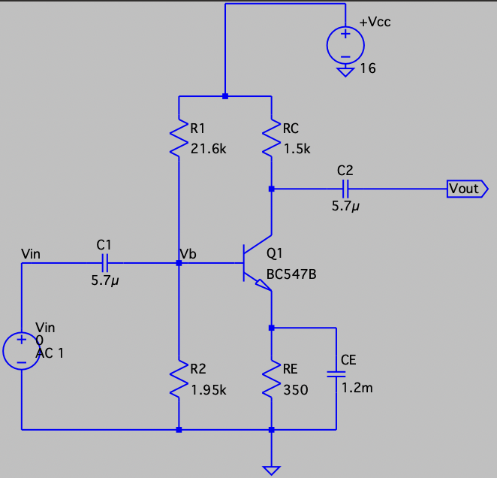

**Fig 3.9:** The final designed RC Coupled amplifier circuit

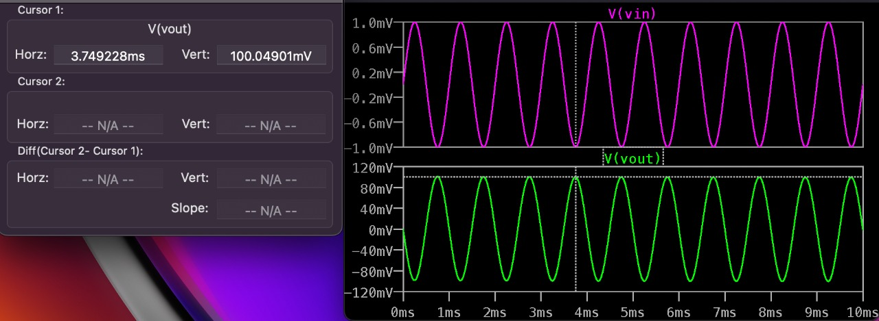

**Fig 3.9(a):** Input v/s Output waveforms

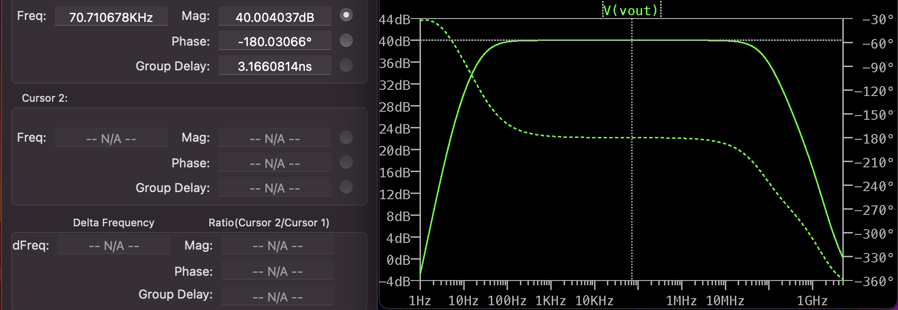

**Fig 3.9(b):** Frequency response curve of the amplifier

**3.3.2 Challenges faced during the project**

* Could not find the exact transistor model that I needed, available in the LTspice software. Hence, chose the transistor BC547B.
* Adjusting the gain precisely to 100 (40dB) by varying the value of the transistors.
* The values of components obtained were not satisfying the objective requirements. So, had to redo the calculations.

**CHAPTER 4**

**REFLECTIONS**

**CHAPTER 4  
REFLECTIONS**

By the end of the Internship, I have acquired the following skills

1. Ability to use KVL and KCL effectively.
2. Checking for linearity of components.
3. LTspice simulation software.
4. Understood the procedure of fabrication of a MOSFET.
5. The behaviour and operation of non-linear electronic components such as diode, BJT, MOSFET etc.
6. The behaviour and operation of combinational circuits such as multiplexers, encoders, decoders etc.

REFERENCES

1. LTspice Wikipedia page
2. LTspice – AN Introduction, Jan Hvolgaard Mikkelsen, 2005, Aalborg Uni., Denmark
3. Basic circuit simulation with LTspice: https://www.allaboutcircuits.com/technical-articles/basic-circuit- simulation-with-ltspice/
4. Cornell Education lecture on LTspice simulation:  
    https://www.classe.cornell.edu/~ib38/teaching/p360/lectures/wk07/l 21/LTspice_lecture.pdf
5. Tutorials Point website, on RC Coupled amplifier using BJT: https://www.tutorialspoint.com/amplifiers/rc_coupling_amplifier.ht m
6. A Simulation of Single Stage BJT Amplifier using LTspice, Mohammad Nizam Ibrahim et. Al., 2016, E-Academia journal
7. YouTube lectures on designing of RC Coupled amplifier